**University of North Texas**

**ADTA 5760-501**

# **Natural Language Processing with Artificial Neural Networks**

**Financial Intelligence: A Generative AI-Powered Q&A System for Corporate Financial Analysis**

**Group Members** – Biniam Abebe, Srilekha Aduvala ,Nithin Marpu, Joshua Terrazas

PART I: Generative AI System for Business

* For this project our group has decided to develop an AI system for a financial company. We decided to focus on how generative AI can be used as a tool to enhance daily operations in the finance world. Our goal is to design a system that can help with tasks such as answering customer questions, giving personalized financial advice/ tips, and helping employees create daily reports and financial summaries. By implementing this LLM into their system, the company should see a reduced workload and make financial services seamless for both clients and staff. The team is excited to explore how deep an impact this AI system can make in the financial industry.

PART II: Business and Technical Requirements of the System

* Our team is developing a generative AI system for a financial company that is to be used to streamline workflow, improve customer satisfaction scores, and support data driven business decisions. The organization we are working with are interested in the end results that AI can drive, from saving employee time, responding to customer’s queries, offering financial advice, and generating financial reports. By implementing this generative AI system into the company's system, this will allow their employees to focus on more difficult tasks while AI manages the background noise that usually gets in the way. The company hopes to give customers a more personalized experience and faster service. It also helps the company stay up to date with technology and modernize their financial services by implementing this AI system.
* The business goals for implementing this LLM-based generative AI model include increasing customer interactions, automating workflow, providing financial advice, and generating up-to-date financial reports for internal use. The system is also expected to close a language gap between clients and employees of all linguistic backgrounds. The goal is to seamlessly integrate this AI system into the company’s system without adding to the daily workload. Instead, the system should alleviate the staff's repetitive workload and allow them to hyper focus on providing personalized experience to their clientele. The system will allow for financial advisors and staff to interact with the AI system to refine and recommend relevant content.
* The group has decided to use Google Cloud Platform (GCP), leveraging Vertex AI to manage, deploy, and fine-tune machine learning workflows. This will be our AI systems platform used to develop the generative AI system. Gemini 2.0 experimental is the large language model (LLM) chosen for this generative AI system. Gemini 2.0 was selected due to its high performance in relaying useful relevant financial information and generate clear human-like responses for any user. We understand that the AI system must be able to support and provide real time APIs for the customers interacting, offer secure data, and offer tracking for audit purposes. Additionally, the system should be able to manage natural language understanding and keep updated with real time data to support business improvements. These features will ensure that the AI system is efficient and delivers high quality data-driven business results that align with the financial services goals of the company.
* AI platform
  + Google Cloud Platform (GCP) using Vertex AI
* Large Language Model (LLM):
  + Gemini 2.0 experimental
* Business Values:
  + Streamline daily workflow
  + Reduce employee workload
  + Improve customer satisfaction scorecards
  + Personalize customer experience
  + Modernize operations
* Business Requirements:
  + Automate daily tasks such as financial reporting/ customer queries
  + Provide financial advice/ tips
  + Integrate AI system seamlessly into workflow
  + Enhance productivity by alleviating staff workload
* Technical Requirements:
  + Real-time APIs for customer interaction
  + Data security
  + Natual Language Processing (NLP) capabilities
  + Real-time data for business improvement

PART III: Data and Cloud Data Storage Requirements

The group accessed Google Cloud Console to create folders needed for the team project. A Google Cloud Storage bucket named “adta5770-docs-folder98" was created. Inside the bucket, a folder named “documents” was created, and a subfolder labeled “pdfs”/ was added inside it. No files are currently shown inside the pdfs folder.

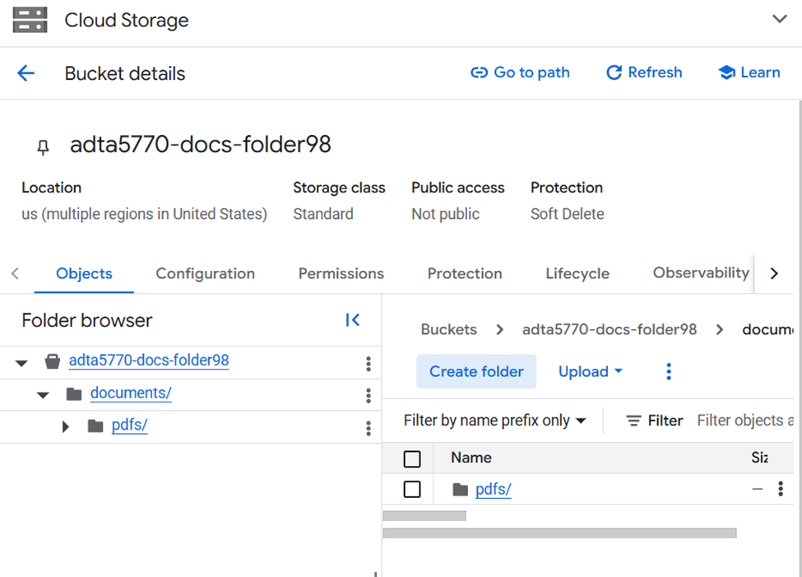

A file named PDFS.zip has been uploaded into the documents folder.

